**Final Coursework**

**PUZZLE GAME**

**By**

**Ashfaq Akbar Sakif(U2080727)**

Software Design (International Year 1)

**Introduction**

In this coursework, I wrote a C++ command-line program that simulates a 3x3 sliding puzzle game. In a sliding puzzle game, 8 tiles with the numerals 1-8 are placed onto a 3x3 square grid. One of the positions is left open for tiles coming from the top, bottom, left, or right (depending on the puzzle configuration). The goal of the game is to slide the tiles around so they appear in order on the puzzle board. When writing this program, user should adhere to the object-oriented programming paradigm. In this program, I used object-oriented analysis, design and implementation of classes. However, I included four UML diagrams or documents that I have produces to plan and understand the system. I have also employed flow chart diagrams for each activity/function of my system, produced a use case, activity and sequence diagrams. These will involve both high-level systems and subsystems and low-level methods and sub procedures involving pseudocode algorithms and flowcharts.

**Aim**

This sliding number puzzle game is a board comprising a 3x3 matrix of numbers that the player is asked to arrange from left to right then top to bottom in order. My aim is to design and implement this game to ensure that the player can only move in the said directions to achieve the winning rearrangement

**Objectives**

The main objective of the Puzzle Game is to design and implement this game to ensure that the player can only move in the said directions (horizontally/vertically) to achieve the winning rearrangement. However, the puzzle game is a board comprising a 3x3 matrix of numbers that the player is asked to arrange from left to right then top to bottom in order. The board, at the beginning has numbers scrambled from 1 to 8. By initiating the game, the user will see the puzzle board with some randomised numbers (1 - 8). There is a free space on the board that the user can swap an adjacent piece horizontally or vertically in order to rearrange the numbers on the board. The user or player can swap any number on this puzzle board. The following diagram shows a sequence of moves from aninitial board(left)tothegoal board(right).

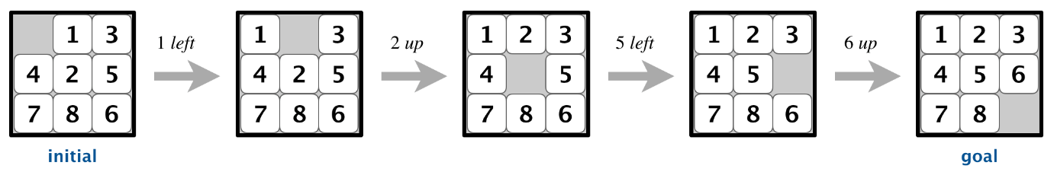

**Methodology**

Sliding Number Puzzle - Artfully headaches! The pieces are to be pushed around over the board until the puzzle is complete. The pieces are numbered so that you will know in which order they should be. You can only move one piece at a time and you do it by clicking on it. When you want to move several pieces, you must click on one piece at a time. The number on each piece tells where in the puzzle it belongs. The piece marked *1* should be in the upper left corner of the slide puzzle. This is how the pieces should be arranged when the puzzle is solved.

Hamming and Manhattan distances.  To measure how close a board is to the goal board, we define two notions of distance. The Hamming distance between a board and the goal board is the number of tiles in the wrong position. The Manhattan distance between a board and the goal board is the sum of the Manhattan distances (sum of the vertical and horizontal distance) from the tiles to their goal positions.

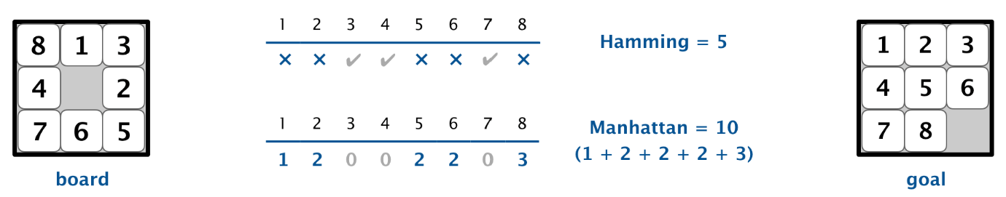

In order to master sliding puzzles, you want to solve them (or attempt to solve them) in portions. Try to solve the top right corner, then the top left corner. From there, you should be able to solve the first row of the puzzle. Then, try to solve the leftmost column, or the puzzle squares directly below the top left corner. Repeat this patten until the entire puzzle is filled in.